Zeppelin Assignment 1 – Mohammed Ali

1. ) Load data into a Spark dataframe

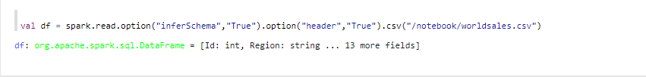

2.) Create Schema

3.) Print the Schema

4.) Aggregate the dataframe via group by “Region” and count

5.) Create a separate dataframe with the above group by results

6.) Create two views using the “createOrReplaceTempView” command

7.) View on “Salesview” from the first dataframe

**“Refer to 7”**

8.) View on “Regionview” from the second dataframe

**“Refer to 7”**

9.) Using SQL select all from “Regionview” view and show in a line graph.

10.) Using SQL, from the “Salesview” view, Select the region and sum of units sold, and group by region

11.) Select from the “Salesview” view – the region and sum of total_profit and group by region and display in a Bar chart

12.) Using SQL select from the “Salesview” view – show the total profit as profit, the total revenue as revenue and the total cost as cost from “Salesview”, group by region.

13.) The client is in the process of opening up a new store and they are looking at the best location to do so - They need to see the avg profit in each region as a percentage (pie chart) compared to other regions.

Sidenote: I used Ambari and Docker since the server for Ambari was not accessible. I tried different ways to access Zeppelin and was unsuccessful. That was until I started to use Docker and installed the container for Apache Zeppelin. From there it was easy to host the server and complete the required queries.